**DEVELOPMENT OF VIRTUAL LEARNING APP**

**USING ANDROID STUDIO**

*Project Report Submitted by*

**Jasmine Glani Mathias**

**(4NM17CS070)**



**UNDER THE GUIDANCE OF**

##### **Mr. Sandeep Kumar Hegde Associate Professor Gd. II**

*in partial fulfillment of the requirements for the award of*

*the Degree of*

***Bachelor of Engineering***

***(Computer Science & Engineering)***

**from**

## Visvesvaraya Technological University

Department of Computer Science and Engineering

NMAM Institute of Technology, Nitte – 574110

(An Autonomous Institution affiliated to VTU Belgaum)

### July 2021



(ISO 9001:2015 Certified), Accredited with ‘A’ Grade by NAAC

: 08258 - 281039 – 281263, Fax: 08258 – 281265

**Department of Computer Science and Engineering**

B.E. CSE Program Accredited by NBA, New Delhi from 1-7-2018 to 30-6-2021

CERTIFICATE

*Certified that the project work entitled*

***“Development of Virtual Learning App using Android Studio”***

*is a bonafide work carried out by*

***Jasmine Glani Mathias***

***(4NM17CS070)***

*in partial fulfilment of the requirements for the award of*

***Bachelor of Engineering Degree*** *in* ***Computer Science*** *and* ***Engineering***

*prescribed by* ***Visvesvaraya Technological University, Belgaum***

*during the year 2020-2021.*

*It is certified that all corrections/suggestions indicated for Internal Assessment have been*

*incorporated in the report deposited in the departmental library.*

*The project report has been approved as it satisfies the academic requirements in respect of the*

*project work prescribed for the Bachelor of Engineering Degree.*

**Signature of Guide Signature of HOD Signature of Principal**

**Semester End Viva Voce Examination**

**Name of the Examiners Signature with Date**

***1.***

***2.***

**ACKNOWLEDGEMENT**

We believe that our project will be complete only after we thank the people who have contributed to make this project successful.

First and foremost, our sincere thanks to our beloved principal, **Dr. Niranjan N. Chiplunkar** for giving us an opportunity to carry out our project work at our college and providing us with all the needed facilities.

Our thanks to our beloved HOD, **Dr. Jyothi Shetty,** for extending support in carrying out this project in the department and providing us with all necessary facilities.

We express our deep sense of gratitude and indebtedness to our guide **Mr. Sandeep Kumar Hegde,** Associate Professor Gd. II, Department of Computer Science and Engineering,for his inspiring guidance, constant encouragement, support and suggestions for improvement during the course for our project.

We express our gratitude to the project coordinator **Mr. Raju K., Mrs. Pallavi K N and Mrs. Asmitha Poojary** for their constant support.

We also thank all those who have supported us throughout the entire duration of our project.

Finally, we thank the staff members of the Department of Computer Science and Engineering and all our friends for their honest opinions and suggestions throughout the course of our project.

**Jasmine Glani Mathias (4NM17CS070)**

#### 

**ABSTRACT**

The educational sector has seen a drastic change in its approach as more resources have been made available to make it prosperous. Among these resources, Virtual learning mobile apps have their worth in gold. Virtual learning apps have come into trend over the last 4-5 years and since their arrival, the overall scenario of education has changed forever. E-learning has accumulated praise from parents and students from all over the world for the methods of learning it brings alongside it. The basic formula of Virtual learning mobile apps is that all the educational stuff that student’s study in their schools and tuitions classrooms has been made available for students in their smartphones from the comforts of their homes. Online learning mobile applications in large numbers have raided Google and Apple Play store. Different types of e-learning apps are available with different ways of teaching style and it is up to the students to select their preferred style of the teaching method.

## TABLE OF CONTENTS

#### Contents Page

**Title Page i**

**Certificate ii**

**Acknowledgement iii**

**Abstract iv**

**Table of contents v****-vii**

**List of figures viii****-ix**

**CHAPTER 1 INTRODUCTION 1-4**

* 1. Overview 2
  2. Problem Statement 2-3
  3. Study Area 3
  4. Objective 3
  5. Motivation 3
  6. Organization of the Report 4

**CHAPTER 2 LITERATURE SURVEY 5-10**

* 1. Existing System 5-9
  2. Proposed System 10

**CHAPTER 3 SYSTEM ANALYSIS & REQUIREMENTS 11-13**

* 1. System Analysis 11
     1. Relevance of platform 11
     2. Relevance of programming language 11
  2. Requirement Analysis 12
     1. Scope and boundary 12
  3. Functional Requirements 12
     1. Software Requirements 12
     2. Hardware Requirements 12
  4. Non Functional Requirements 13

**CHAPTER 4 SOFTWARE APPROACH 14-15**

* 1. About Android Framework 14
  2. About Kotlin 14-15
  3. Firebase 15
  4. Android Studio 15

**CHAPTER 5 SYSTEM DESIGN 16-21**

* 1. High Level Design Architecture 16
  2. Low Level Design Architecture 17-21

5.2.1 Sequence Diagram/DFD 17

* + 1. Use Case Diagram 18-20
    2. Activity Diagram 20-21

**CHAPTER 6 SYSTEM IMPLEMENTATION 22-25**

6.1 Software Approach

6.1.1 Design of User Interface 22

6.2 Module 22-25

6.2.1 User Registration Module 22

6.2.2 Menu Module 23

6.2.3 My Course Module 23-24

6.2.4 Chapter Test Module 24

6.2.5 Search Module 24

6.2.6 Profile Module 24

6.2.7 Settings Module 24-25

**CHAPTER 7 SYSTEM TESTING 26-27**

7.1 Introduction 26

7.1 Unit Testing 26-27

7.1 Integration Testing 27

**CHAPTER 8 RESULTS AND DISCUSSIONS 28-36**

8.1 Splash Scree and App Tour 28-29

8.2 Login and Registration 29-31

8.3 Menu 31-32

8.4 My Course 32-33

8.5 My Profile 33

8.6 Notification and Settings 34

8.7 Test 35

8.8 Discussion 36

**CHAPTER 9 CONCLUSION AND FUTURE WORK 37**

9.1 Conclusion 37

9.2 Future Work 37

**REFERENCES 38**

## LIST OF FIGURES

Figure 5.1 High Level Design Architecture 16

Figure 5.2.1 Sequence Diagram for User 17

Figure 5.2.2a Use Case Diagram to Login and Register for User 19

Figure 5.2.2b Use Case Diagram for User 20

Figure 5.2.3 Activity Diagram for User 21

Figure 8.1.1 Splash Screen 28

Figure 8.1.2 App Tour Screen 1 28

Figure 8.1.3 App Tour Screen 2 29

Figure 8.1.4 App Tour Screen 3 29

Figure 8.2.1 Welcome Screen 29

Figure 8.2.2 User Login 29

Figure 8.2.3 Forgot Password 30

Figure 8.2.4 OTP Verification 30

Figure 8.2.5 Reset Password 30

Figure 8.2.6 Reset Password Successful 30

Figure 8.2.7 User Registration 30

Figure 8.2.8 Mobile Number Register 31

Figure 8.2.9 OTP Register 31

Figure 8.2.10 Register Successful 31

Figure 8.3.1 Drawer 31

Figure 8.3.2 Home 31

Figure 8.3.3 My Course 31

Figure 8.3.4 My Profile 32

Figure 8.3.5 Notification 32

Figure 8.3.6 Settings 32

Figure 8.4.1 Ongoing Course 32

Figure 8.4.2 Ongoing Course Details 32

Figure 8.4.3 Course Completion 33

Figure 8.4.4 Course Completion Certificate 33

Figure 8.5.1 View Profile 33

Figure 8.5.2 Edit Profile 33

Figure 8.5.3 Change Password 33

Figure 8.6.1 Notification 34

Figure 8.6.2 Notification Settings 34

Figure 8.6.3 Privacy Policy 34

Figure 8.6.4 Terms of Service 34

Figure 8.7.1 Test 35

Figure 8.7.2 Submit Test 35

Figure 8.7.3 Test Completed 35

Figure 8.7.4 Course Result 35

Figure 8.7.5 Review Result 35

## CHAPTER 1 INTRODUCTION

Learning in their free time will lead to better performance and higher efficiency, especially because online eLearning software will enable them to revisit any information they need, whenever they need it. According to IBM statistics, eLearning can increase productivity by50%. For many years’ schools all across the world have used many different practices to help students understand the difficult curriculum. Learners change their attitude about learning and their personality will affect their own learning. Now that most of the world is technologically advanced some schools and colleges are now online and believe that it will help students. Change in technology brought new hardware like portable computers, which made it very easy for learners to access course material online. Today, many people are using tablets and smart-phones for online classes and web seminars or webinars.

Technology has become an imperative part of our life without which we cannot survive. Education is one such area that is enormously impacted by the growing use of technology. E-learning is referred to intentional use of electronic media and information in learning process in schools and also other forms of learning, here “E” denotes “Electronic”. Many other terms are used to describe e-learning such as web-based learning, online learning etc. Nowadays, eLearning is used to educate people of all different ages. It is a relatively advanced and new way of educating learners using technology as an instructional medium. In recent years, governments of both developed and under-developed nations have become increasingly excited about the possibilities of online learning to deliver cost effective, easily accessible and ever - current education to all ages and social backgrounds, regardless of time and geography.

This particular work, titled, “Virtual Learn” attempts to improve lives through learning. It enables anyone anywhere to create and share educational courses and to enroll in these educational courses to learn. It considers the market place model the best way to offer valuable educational content to our users. It needs rules to keep the platform safe for users and instructor community.

**1.1 OVERVIEW**

Education has become one of the fastest growing “businesses” in recent years. It seems like there is a new commercial every week for a new online university, technical, or school of business. Online education has become more popular in today’s fast paced society. Online courses allow learners to take courses from different locations. It is not just enough for the students to sit inside the classroom and learn their subjects theoretically, It will not fetch them any practical knowledge. Thus, E-learning benefits the learners by giving deep knowledge of the subjects long with practical knowledge in the simplest and easily understandable way.

Our app called Virtual Learn enables anyone anywhere to create and share educational courses and to enroll in these educational courses to learn. By connecting learners all over the to the best lecture videos, Virtual Learn helps individuals reach their goals and pursue their dreams.

The **Android operating system** is the largest installed base among various mobile platforms across the globe. It’s user-friendly, has huge community support, provides a greater extent of customization, and a large number of companies build Android-compatible smartphones. As a result, the market observes a sharp increase in the demand for developing Android mobile applications, and with that companies need smart developers with the right skill set. At first, the purpose of Android was thought of as a mobile operating system. However, with the advancement of code libraries and its popularity among developers of the divergent domain. Therefore, developing our app using android studio and using the language kotlin.

### PROBLEM STATEMENT

The prospect of having an entire university experience compacted into a personal electronic device is unusual to say the least. It can be unnerving for students who have only ever known traditional classroom settings. Traditionally, a degree of passivity is expected during lectures, particularly when note-taking and listening, while discussion with tutors is allotted a limited time. Online learning demands springing into action, accepting course material in a variety of multimedia formats, and taking part in online discussions which can continue indefinitely.

However, in order to overcome this problem, an open heart and mind is necessary to be able to accept change and reap the many benefits of virtual learning. Secondly, an understanding of the advantages of online education is essential. You can then utilize all of the benefits e-learning can afford you – empowering flexibility, personal tutor guidance, worldwide contact network, 24/7 access to course materials and student support. Once you get started on your online course, you may wonder how you ever learned any other way.

### STUDY AREA

Learning field is highly changing due to different methods and technologies that are introduced every now and then. It is important to have a understandable and faster way of learning for the learners. Thus, development in the methods of learning is very important and one such method is e-learning. This method provides various benefits:

Reduction in costs, Flexibility in Learning Schedules, Consistency in teaching content and learning, Ease of development, modification and updating of content, Tracking the progress with immediate feedbacks. This is one of the efficient method in the field of learning.

### OBJECTIVE

The objectives of this proposed system include:

* To build a smartphone app that will benefit the Students, Research Scholars, IT enthusiasts etc.
* To provide a system that enables the users to choose among wide variety of courses from certified instructors.
* To enable the users to test their skills through variety of tests.

### MOTIVATION

The traditional learning approaches are all met by time constraints, the sessions sprawl over classes that range from 30 minutes to an hour. Traditional or conventional education system is the kind of teaching methods that involves imparting education to children through face-to-face interaction on daily basis between teacher and a student. Online courses connect learning and interactive media available to make learning interesting and engaging as possible. Over the period, textbooks and lecture notes helped students get past learning.

### ORGANIZATION OF THE CHAPTERS

The project report has been organized under ten chapters, which are as follows:

**Chapter I:** Introduces to the main idea of the project. It gives a brief knowledge about the aim and methodology of the same.

**Chapter II:** It includes literature survey of related works.

**Chapter III:** Discusses the system requirements that are needed for the project. These include functional requirements, non-functional requirements, user requirements and hardware requirements.

**Chapter IV:** Includes the software approach

**Chapter V:** Includes the system design details which includes flowchart, sequence diagram, use case diagram and activity diagram.

**Chapter VI:** Includes the implementation details of project, steps are explained in detail. It deals with software approach.

**Chapter VII:** Deals with system testing concepts and various test cases for the project.

**Chapter VIII:** Discuss the results of the project.

**Chapter IX:** Outlines conclusions and future work that can be done.

**CHAPTER 2**

**LITERATURE SURVEY**

### 

### EXISTING SYSTEM

For our literature survey, we have taken eight research papers for our study:

* Development of Game-Based M-Learning Apps for Preschoolers by Dionisia Laranjeiro aimed to develop game-based learning apps for preschoolers, using the DBR methodology to support technological development with scientific research in the area of technologies in education. The information collected in the three phases (preliminary study, development and evaluation), the involvement of the target audience (educator and children) and the triangulation with theoretical studies and existing apps guided the technological development, resulting in robust products and contributions to the theory. In addition, a website collects children’s play data, which is represented with flowers in a virtual world, to illustrate their participation/collaboration for a better future.
* Development of android-based learning application in EFI materials for vocational schools by N A Handoyono and Rabiman explains the design and analysis of the performance of android-based learning application on EFI service material. This type of research is Research and Development with a 4D model. The technique of collecting data uses observation and questionnaires. This development model consists of 4 stages, namely: (1) define; (2) design; (3) develop; and (4) disseminate. Based on the discussion of the development of an Android-based learning application on EFI material, it can be concluded that the Android-based learning application on the EFI material developed using Appinventor 2 is accessed online. This learning application is effectively applied in learning and makes it easier for students to get teaching material.
* Interactive Learning Media Based on Android for Computer Programming Course by A D Achmad, A Achmad, and Z M Putra uses R&D method for this research. R&D is a research method used to produce certain products and test the effectiveness of these methods. Interactive learning media based on Android can be used as a practical learning media to help students to understand learning material more which is equipped with interactive future; auto complete syntax and function in the code editor. This application can also assist lecturers in directly monitoring the results of student evaluation during lecture time.
* Development of e-learning and statistical simulation for explorative data analysis based on android Nia Gracelita explains e-learning system and statistical simulation for EDA courses in the android-based environment. In its development, we use the Java programming language and integrate with R Shiny for statistical simulations in the form of data processing. Exploratory Data Analysis (EDA) is one of the basic statistics subjects that needs to be studied as a basis for higher processing and analyzing data. This subject is taught in class, but these activities are not necessarily enough to understand the subject. This problem can be solved by learning independently. However, in the process of learning independently there are obstacles such as the unavailability of suitable material so that a search is needed which may not produce anything or if the material is available in book or textbook format, the material is less flexible in its use. An e-learning system needs to be developed to solve these problems. In addition, simulation can also help students' understanding in building knowledge base. However, the system is still in the early stages of development so that the features contained in this system still consist of basic features, such as material access, data processing, and discussion forums. This system can continue to be developed so that it can become a better system with features that can further support the learning activities of EDA.
* Developing Android Based English Vocabulary Learning Materials for Primary School Students by Surya Pratama and Adi Jaya Putra intended to develop an android bases application for English vocabulary learning for primary school students. By implementing Design and Development model the researcher underwent 3 staged Design, Development, Evaluation. Through the use of questionnaire and interview guide, the needs were full-filled. The smartphone app was tested and evaluated by English teachers and technology experts. The result showed that application has good quality and ready to be deployed.
* Development and Application of an App for Virtualized Learning of Scientific and Medical Terminology by L. Rivas uses iterative method for developing the app. It goes with the collection of scientific terms, Design and development of the software

application, analyzing, Evaluation, expanded project implementation, Presentation aimed to those persons responsible of the curriculum, Dissemination of the tool to the university students. Selection of the most relevant scientific and medical terms, classified in categories, by each member of the scientific team. As the result, Selection of the most relevant scientific and medical terms, classified in categories, by each member of the scientific team.

* Android based e-learning tutorial for mathematics teachers by Y Roza, I Daqiqil, S N Siregar, S Salam and A Adnan uses Waterfall method and used android based. The product has been used by mathematics teachers for testing product practicality. The product is assessed based on the aspect of cosmetics and program. The product then revised based on input from the teacher. Implementing e-tutorial can be used as an alternative method in the learning process or training. The advantages of android based e-tutorials because it can be accessed anywhere and anytime, thus increasing participants' control of learning. This new e-tutorial contains two examples of learning models, so there is still an opportunity to develop examples of other learning models for different levels of school.
* Application Based Android as A Development of English Learning Media by Muzayyanna, Riswandi, Helmi, Akla aimed to describe the conditions and potential of English language learning media development-based android; Describe English learning media-based android; analyze the effectiveness of English learning applications-based android; analyze efficiency; analyze the attractiveness of English instructional media through an android application.

|  |  |  |  |  |  |  |
| --- | --- | --- | --- | --- | --- | --- |
| **SL NO** | **AUTHORS** | **YEAR** | **METHODOLOGY** | **DATASET** | **ADVANTAGE** | **DRAWBACK** |
| 1 | Dionisia Laranjeiro | 2021 | DBR – preliminary study,development, Evaluation. | Play Data-  Observation, interview with educator | Guiding document for children,robust,increase knowledge base. | Inavailability of company’s team due to several task and deadlines running at same time.  The involvement of children and educator was restricted to timetable. |
| 2 | N A Handoyona,  Rabiman | 2020 | 4D Model-Define, Design, Develop, Disseminate | EFI Material-  Observation, Questionnaire | It allows student to get information efficiently and can be accessed anywhere ,anytime. | The feasibility test result categories in good which can be further improved to excellent level. |
| 3 | A D Achmad, A Achmad,  Z M Putra | 2020 | R & D Method- Analysis, Design, Development, Evaluation. | Language Data-  Questionnaire Instrument | Interactive Features, auto complete syntax and function in code editor.  It can also assist lecturers in directly monitoring the result of student. | Survey says, not all the student agree that it can help students to understand the learning material. |
| 4 | Nia Gracelita | 2020 | Software Development Life Cycle-Waterfall Model | EDA data-  Interview with EDA lecturers,  Questionnaire | Helps to deal with the unavailabity of suitable material.  Simulation helps in building knowledge base. | The system still consists of only basic features such as material access, data processing and still needs to be improved by supporting the learning activities of EDA. |

|  |  |  |  |  |  |  |
| --- | --- | --- | --- | --- | --- | --- |
| **SL NO** | **AUTHORS** | **YEAR** | **METHODOLOGY** | **DATASET** | **ADVANTAGE** | **DRAWBACK** |
| 5 | Surya Pratama, Adi Jaya | 2020 | Design & Development Model-Design,develop and evaluate. | Vocabulary-  Questionnaire ,Interview Guide | Help in improving the vocabulary about the topics learning in school. | This model also requires the teacher to be significantly involved.  The app contains only the vocabulary part,which can be further improved. |
| 6 | L Rivas | 2018 | Iterative Model-  Collect the data  Design and develop  Analyse  Evaluate  deploy | Scientific, Medical Terms-Observation,questionnaire | Help in improving the effectiveness.  Provide free resources,easy to access and immediate availability. | Lack of knowledge on terminologies will be effecting the system. |
| 7 | Y Roza, S N Siregar, S Salam and A Adnan | 2018 | Waterfall method | Mathematics Data-  assessment on program and cosmetic aspect. | Increases the mastery of knowledge and teachers  consider learning more fun, faster and easier than traditional tutorials  accessed anywhere and anytime. | The points that get the lowest score are about the use of animation. |
| 8 | Muzayyanna, Riswandi, Helmi, Akla. | 2018 | R & D -research and information collecting,planning,preliminary development,preliminary test,product revision,operation testing,final product review | English Data-  Researh information.  Observations,questionnaires and tests. | Allows students to increase their learning motivation, creativity and  learn independently. | Still needs to be improvement in efficiency, workable in other operating systems than android. |

### PROPOSED SYSTEM

To build a smartphone app that will benefit the Students, Research Scholars, IT enthusiasts Etc. To provide a system that enables the users to choose among wide variety of courses from certified instructors. To enable the users to test their skills through variety of tests. To enable the user to browse and watch the courses which they require.

The Proposed system consist of a virtual Learning app developed using android studio. At first there is a User registration activity to be done if the user is using the app for first time. The user should be registered to use the mobile app features. This module would involve sign-up, sign-in. Once the user has successfully registered, he can login which takes the user to the home page. In the Home page enable the user to see all the available courses. In the app and if user clicks the navigation bar, the Menu Page will be appearing. Menu Page contains the Home, profile, settings, notification, my course and logout options. My Course enables the users to see the courses in which they are enrolled. Chapter module test contains MCQ’s of the enrolled courses. In search option users can search from wide variety of courses. Profile option enables the user to check their profile or change password. In settings option Contains notification settings and privacy policy.

## CHAPTER 3 SYSTEM ANALYSIS AND REQUIREMENTS

### SYSTEM ANALYSIS

#### Relevance of Platform

#### Android Studio is Android's official IDE. It is purpose-built for Android to accelerate your development and help you build the highest-quality apps for every Android device. The code editor helps you write better code, work faster, and be more productive by offering advanced code completion, refactoring, and code analysis. As you type, Android Studio provides suggestions in a dropdown list. Simply press Tab to insert the code.

#### Android Studio's Apply Changes feature lets you push code and resource changes to your running app without restarting your app—and, in some cases, without restarting the current activity. This flexibility helps you control how much of your app is restarted when you want to deploy and test small, incremental changes while preserving your device's current state.

#### Relevance of Programming Language

#### Kotlin is designed to be an industrial-strength [object-oriented](https://en.wikipedia.org/wiki/Object-oriented_programming) language, and a "better language" than [Java](https://en.wikipedia.org/wiki/Java_(programming_language)), but still be fully interoperable with Java code, allowing companies to make a gradual migration from Java to Kotlin.

#### Kotlin supports the specification of a "primary constructor" as part of the class definition itself, consisting of an argument list following the class name. This argument list supports an expanded syntax on Kotlin's standard function argument lists, that enables declaration of class properties in the primary constructor, including visibility, extensibility and mutability attributes. Additionally, when defining a subclass, properties in super-interfaces and super-classes can be overridden in the primary constructor.

### REQUIREMENT ANALYSIS

#### Scope and Boundary

Virtual learning has proven to be more effective than traditional and hence more and more educational institutions are inculcating visual based learning. Accessing the lecturers that are provided online is possible on a system sitting at home rather than having to travel miles to reach schools and attend classes. E- learning tries to save the users’ time and they do not have to entirely spend their schedules in schools instead can divide their time for work and learning equally. The users of our software mostly being students would want the platform to be more engaging and interactive. The platform should be visually pleasing so that the users find it more interesting to work on and makes their learning process fun and productive.

### FUNCTIONAL REQUIREMENTS

#### Software Requirements

The software requirements are description of features and functionalities of the target system. Requirements convey the expectations of users from the software product. The requirements can be obvious or hidden, known or unknown, expected or unexpected from client’s point of view.

Important software requirements for the project include:

* Firebase
* Kotlin 1.3.6, Android Framework
* Android Studio

#### Hardware Requirements

Major hardware requirements for the project include:

* CPU type can be Intel i3 processor or above
* RAM size is 4GB or above
* Hard disk capacity 3 GB
* Input device is Android mobile screen
* Output device is Android mobile screen

### NON-FUNCTIONAL REQUIREMENTS

In [systems engineering](https://en.wikipedia.org/wiki/Systems_engineering) and [requirements engineering,](https://en.wikipedia.org/wiki/Requirements_engineering) a non-functional requirement (NFR) is a [requirement](https://en.wikipedia.org/wiki/Requirement) that specifies criteria that can be used to judge the operation of a system, rather than specific behaviours. Non-functional requirements are conditions under which the system must be able to function and the quality the system must have. It defines how a system is supposed to be.

* Performance:
  + The application should provide easy and fast response without hindering the user experience.
  + Performance shall not decrease with time and usage.
* Flexibility:
  + Android Studio is quite extensible, supports programming languages such as Java, Kotlin. And it is free as an open source software.
  + Is able to analyze and give the output as quickly as possible.
* User-friendly:
  + The ability to execute the code from the browser, with the results displayed in the android emulator.
  + Displaying the result of computation using different kinds of android emulator is possible.
  + They are great for showcasing your work You can use both the code and design for work.
* Scalability:
  + The app should be capable to adapt itself to the changing data usage as the time progresses.
* Screen Adaption:
  + Application should be able to render its layout to different screen sizes

and orientation along with automatic font size adjustment and rendering

of images.

## CHAPTER 4 SOFTWARE APPROACH

### ABOUT ANDROID FRAMEWORK

The Android OS exposes the underlying libraries and features of the Android device that are using a Java API. This is what is known as the Android framework. The framework exposes a safe and uniform means to utilize Android device resources.

* Activity Manager:  Android Activities are the components that house the user interface that app users interact with. As end-users interact with the Android device, they start, stop, and jump back and forth across many applications. Each navigation event triggers activation and deactivation of many activities in respective applications.
* Window Manager: The Window Manager helps in delivering a customized app experience. Apps can fill the complete screen for an immersive experience or share the screen with other apps. Android enables this by allowing multi-windows for each app.
* Location Manager: Most Android devices are equipped with GPS devices that can get user location using satellite information to which can go all the way to meters precision. Programmers can prompt for location permission from the users, deliver location, and aware experiences.
* Resource Manager: Android app usually come with more than just code. They also have other resources such as icons, audio and video files, animations, text files, and the like. Android helps in making sure that there is efficient, responsive access to these resources. It also ensures that the right resources are delivered to the end-users.

View system, Notification manager and many more.

### ABOUT KOTLIN

Kotlin programming language is now its preferred language for Android app developers. Since the release of Android Studio 3.0 in October 2017, Kotlin has been included as an alternative to the standard Java compiler. The Android Kotlin compiler produces Java 6 bytecode by default (which runs in any later JVM), but lets the programmer choose to target Java 8 up to 15, for optimization, or allows for more features, e.g., Java 8 related with Kotlin 1.4, and has experimental record class support for Java 16 compatibility. Kotlin support for JavaScript (i.e., classic back-end) is considered stable in Kotlin 1.3 by its developers, while Kotlin/JS (IR-based) in version 1.4s considered alpha. Kotlin with extension .kt.

### FIREBASE

Firebase is a mobile and web application development platform developed by Firebase, Inc in 2011, then acquired by Google in 2014.As of October 2018, the Firebase platform has18 products, which are used by 1.5 million apps Firebase provides backend as a service. The service provides application developers an API that allows application data to be synchronized across clients and stored on Firebase's cloud. Firebase Storage provides secure file uploads and downloads for Firebase apps, regardless of network quality. The developer can use it to store images, audio, video, or other user-generated content. Firebase Storage is backed by google cloud storage.

* 1. **ANDROID STUDIO**

Android Studio is the official [integrated development environment](https://en.wikipedia.org/wiki/Integrated_development_environment) (IDE) for [Google](https://en.wikipedia.org/wiki/Google)'s [Android](https://en.wikipedia.org/wiki/Android_(operating_system)) [operating system](https://en.wikipedia.org/wiki/Operating_system), built on [JetBrains](https://en.wikipedia.org/wiki/JetBrains)' [IntelliJ IDEA](https://en.wikipedia.org/wiki/IntelliJ_IDEA) software and designed specifically for [Android development](https://en.wikipedia.org/wiki/Android_software_development). It is available for download on [Windows](https://en.wikipedia.org/wiki/Windows), [macOS](https://en.wikipedia.org/wiki/MacOS) and [Linux](https://en.wikipedia.org/wiki/Linux) based operating systems or as a subscription-based service in 2020. t is a replacement for the [Eclipse Android Development Tools](https://en.wikipedia.org/wiki/Eclipse_(software)#Android_Development_Tools) (E-ADT) as the primary IDE for native Android application development.

## CHAPTER 5

**SYSTEM DESIGN**

### 

### 5.1 HIGH LEVEL DESIGN ARCHITECTURE

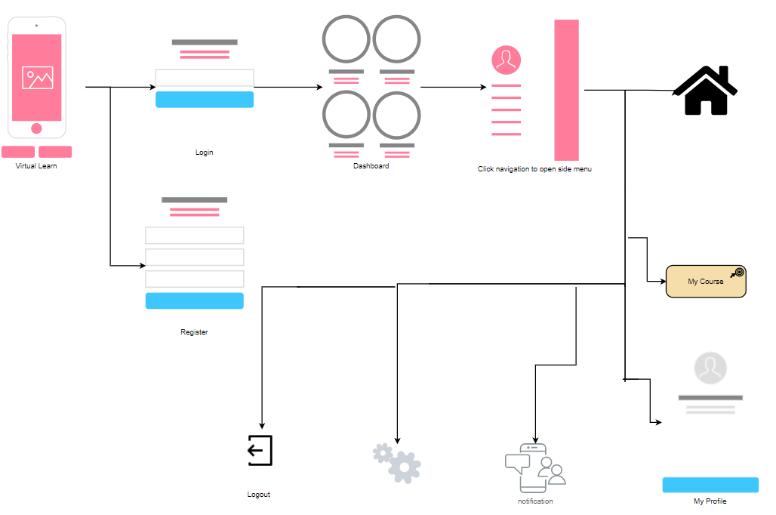

*Figure 5.1: High Level Design Architecture*

### LOW LEVEL DESIGN ARCHITECTURE

#### Sequence Diagram /DFD

A sequence diagram shows object interaction arranged in time sequence. It describes interactions among classes in terms of an exchange of messages over time. It is also called as event diagram. A sequence diagram is a good way to visualize and validate various run time scenarios. These can help to predict how a system will behave and to discover responsibilities a class may need to have in the process of modelling the new system. Messages are arrows that represent communication between the objects. Lifelines are vertical dashed lines that indicate the object presence over time.

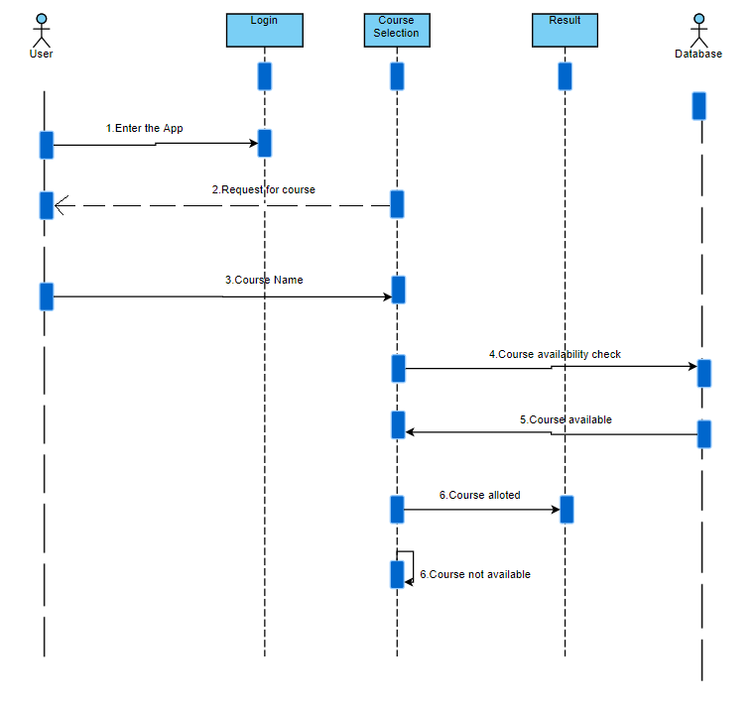

*Figure 5.2.1: sequence diagram for User*

1. **Use Case Diagram**

A use case diagram is a dynamic or behavior diagram in [UML](https://www.smartdraw.com/uml-diagram/). Use case diagrams model the functionality of a system using actors and use cases. Use cases are a set of actions, services, and functions that the system needs to perform.

* The use cases are mainly composed of narrative text. Hence, unlike many other modelling techniques, the nontechnical stake holders (e.g., customers, end users, salesperson etc) are also able understand the model for the software system. This means that feedback can be obtained at a very early stage of the development from the customers and the end users.
* Another major advantage of use case modelling is that it requires the identification of exceptional scenarios for the use cases. This helps in discovering subtle alternate requirements in the system.
* The use case model can be utilized in several other aspect of software development as well, for example: Project Planning, Test Case Preparation and User Documentation.
* The use case diagram provides a comprehensive summary of the whole software system in a single illustration.

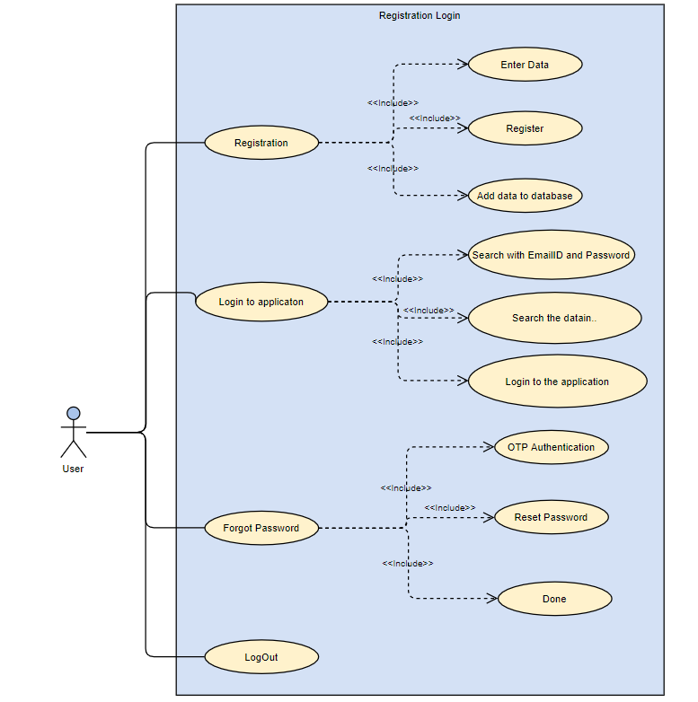

*Figure 5.2.2a: Use case diagram to Login and register for User*

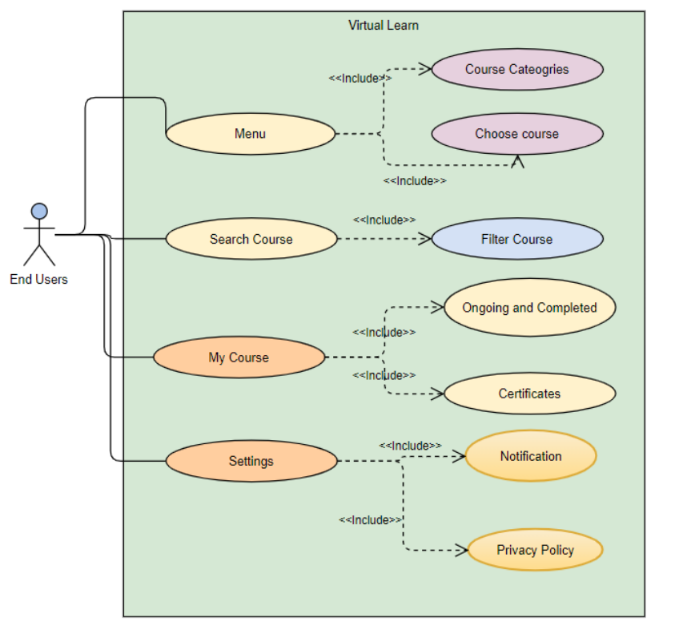

*Figure 5.2.2b: Use case diagram for User*

#### 5.2.3. Activity Diagram

Activity diagram is another important diagram in UML to describe the dynamic aspects of the system. Activity diagram is basically a flowchart to represent the flow from one activity to another activity. The activity can be described as an operation of the system. The control flow is drawn from one operation to another. This flow can be sequential, branched, or concurrent. Activity diagrams deal with all type of flow control by using different elements such as fork, join, etc. Activity diagrams are not only used for visualizing the dynamic nature of a system, but they are also used to construct the executable system by using forward and reverse engineering techniques.

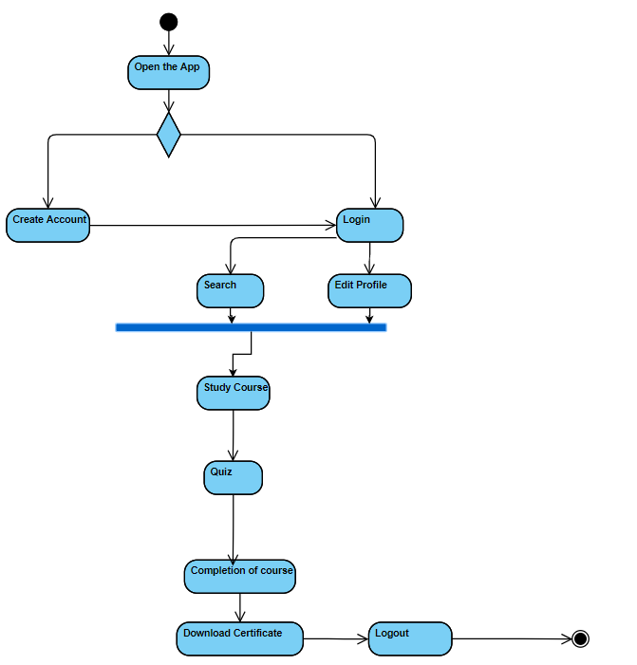

*Figure 5.2.3: Activity diagram for a User*

**CHAPTER 6**

**SYSTEM IMPLEMENTATION**

### 6.1 SOFTWARE APPROACH

#### 6.1.1 Design of User Interface

To simply put in words, a mobile application development platform is a suite of tools,

services, and technologies, It allows anyone to assemble various features and

elements. Also,allows to design, develop, test,deploy, and maintain mobile application

across multiple platforms , devices , and networks. Maintaining consistency and

uniformity in all pages and same goes with styling , is very important . Getting

familiarized to the interface is time taking, hence maintaining consistency in elements

like layout, color and font makes it easier and appealing to the user.

User Interface (UI) Design focuses on anticipating what users might need to do and

ensuring that the interface has elements that are easy to access, understand, and use

to facilitate those actions. UI brings together concepts from interaction design, visual

design, and [information architecture](https://www.usability.gov/what-and-why/information-architecture.html).

### 6.2 MODULES

The app mainly contains these following modules: User registration module, Menu

module, My Course module, Chapter module test, Search module, Profile module,

Settings module.

**6.2.1 User Registration Module:**

User will be provided with 2 option for using the app namely Registration, Login.

Case A: Login, If user has an account.

Step1: Enter Username.

Step 2: Enter Password.

Step 3: Click Login.

Case B: Register, If user is using the app for the first time.

Step 1: User is asked to enter his mobile number.

Step 2: enter OTP received for verification.

Case a: valid OTP- User will be redirected to personal details screen.

Case b: Invalid OTP- a invalid OTP popup is shown and user can

click resend OTP.

Step 3: Registration- successful registration redirects to success screen.

Step 4: Click Let’s get started screen to move to Homepage.

Case C: Forgot Password, If user already has an account and forgot password.

Step 1: Click forgot password in the Login page

Step 2: Enter the mobile number.

Step 3: Enter OTP received for verification.

Step 4: Enter New password.

Step 5: Enter Confirm password.

Step 6: Click Reset Password.

**6.2.2 Menu Module:**

Once user logs in, its directed to Home Page which has greeting with "Hello!" followed by username and homepage contains list of contents, categories, choice your course, top courses in all categories and a navigation button. Once navigation button is clicked

Case A: Home – redirecting to home screen.

Case B: My Course – redirecting to my course screen.

Case C: My Profile – redirected to my profile page, containing user profile, completed

course details, Personal details.

Case C: Notification - redirect to notification screen. Page contains all notification for

particular user order by latest notification. Upon clicking the

notification, details of the notification is shown.

Case D: Settings- redirected to settings Screen.

Case E: Logout – Exit from the app.

Step 1: Click logout.

Step 2: Confirmation dialog is shown.

Case a: Confirm - User is logged out of the app by clicking confirm.

Case b: Cancel - Confirmation dialog is closed upon click.

**6.2.3 My Course Module:**

Case A: Ongoing: List of ongoing courses.

Step 1: continue with particular ongoing course on click of a course.

Case B: Completed: List of all completed courses.

Step 1: View certificate.

Step 2: List of chapter details of each course when clicked.

**6.2.4 Chapter Test Module:**

Quiz is conducted in between the chapters of course. Contains MCQ’s of enrolled

course.

**6.2.5 Search Module:**

Page can be used by the user to search a course of their interest.

Case A: Search for a course.

Case a: Course found - show the user searched course.

* User can select searched course and watch it.

Case b: Course not found - show course not found.

Case B: Top Searches - lists all the top searched courses.

Step 1: Clicked course is shown to the user.

Step 2: Watch the particular course.

Case C: Search by Category - lists all the categories of courses.

Step 1: Clicked category's courses are shown.

Step 2: User can select course.

Step 3: Watch the particular course.

Case D: Filter - bottom sheet is opened, contains searchable categories and duration.

Case a: Apply filter.

* User can select filter from categories and duration.

Case b: Clear all- clears all previously selected filters.

**6.2.6 Profile Module:**

Enables the user to check their profile or change password. It contains user profile,

completed course details, personal details.

Case a: Profile

* Change image: User can change profile picture.
* User can update his personal details provided during registration.

Case b: Privacy - User can update current password.

Step 1: Enter current password.

Step 2: Enter new password.

Step 3: Enter confirm password.

Step 4: Click on reset password.

**6.2.7 Settings Module:**

It contains user settings like notification setting, privacy policy, terms of service.

Case A: Notification setting - settings to show or hide notification from app.

Case B: Privacy Policy - contains the all the privacy related terms.

Case C: Terms of Service - This page contains all terms related to the service.

## CHAPTER 7

## SYSTEM TESTING

### INTRODUCTION

Software testing is a process used to identify the correctness, completeness and quality of the developed software. Testing is the process of questioning a product in order to evaluate it, where the questions are things the tester tries to do with the product and the product answers with its behaviour in reaction to probing of the tester.

Testing phase is performed after coding to detect all the errors and provide quality assurance and ensure reliability of the software. Testing is vital to the success of the system. During testing, the software to be tested is executed with a set of test cases, and the behaviour of the system for the test cases is evaluated to determine if the system is performing as expected. Clearly the success of testing in revealing errors depends critically on the test cases.

### UNIT TESTING

Unit Testing is a level of software testing where individual units/ components of a software are tested. The purpose is to validate that each unit of the software performs as designed. A unit is the smallest testable part of any software. It usually has one or a few inputs and usually a single output. In procedural programming, a unit may be an individual program, function, procedure, etc. In object-oriented programming, the smallest unit is a method, which may belong to a base/ super class, abstract class or derived/ child class. (Some treat a module of an application as a unit. This is to be discouraged as there will probably be many individual units within that module.) Unit testing frameworks, drivers, stubs, and mock/ fake objects are used to assist in unit testing.

The benefits of Unit Testing are:

* Unit testing increases confidence in changing/ maintaining code. If good unit tests are written and if they are run every time any code is changed, we will be able to promptly catch any defects introduced due to the change. Also, if codes are already made less interdependent to make unit testing possible, the unintended impact of changes to any code is less.
* Codes are more reusable. In order to make unit testing possible, codes need to be modular. This means that codes are easier to reuse.
* Development is faster. If you do not have unit testing in place, you write your code and perform that fuzzy ‘developer test’ (You set some breakpoints, fire up the GUI, provide a few inputs that hopefully hit your code and hope that you are all set.) But, if you have unit testing in place, you write the test, write the code and run the test. Writing tests takes time but the time is compensated by the less amount of time it takes to run the tests; You need not fire up the GUI and provide all those inputs. And, of course, unit tests are more reliable than ‘developer tests’. Development is faster in the long run too. The effort required to find and fix defects found during unit testing is very less in comparison to the effort required to fix defects found during system testing or acceptance testing.
* The cost of fixing a defect detected during unit testing is lesser in comparison to that of defects detected at higher levels. Compare the cost (time, effort, destruction, humiliation) of a defect detected during acceptance testing or when the software is live.
* Debugging is easy. When a test fails, only the latest changes need to be debugged. With testing at higher levels, changes made over the span of several days/weeks/months need to be scanned.
* Codes are more reliable.

### INTEGRATION TESTING

Integration Testing is a level of software testing where individual units are combined and tested as a group. The purpose of this level of testing is to expose faults in the interaction between integrated units. Test drivers and test stubs are used to assist in this test.

Integration Testingis the testing performed to expose defects in the interfaces and in

the interactions between integrated components or systems.

Component Integration Testing**:**

* Testing performed to expose defects in the interfaces and interaction between integrated components.

System Integration Testing**:**

* Testing the integration of systems and packages; testing interfaces to external organizations (e.g. Electronic Data Interchange, Internet).

**CHAPTER 8**

**RESULTS AND DISCUSSION**

**8.1 Splash Screen and App Tour Screen:**

Figure 8.1.1 shows the splash screen which will be visible for few seconds**.** Figure 8.1.2 is the first onboarding screen of the app. Figure 8.1.3 is the second onboarding screen of the app. Figure 8.1.4 is the third onboarding screen of the app which will lead to the login or register screen.

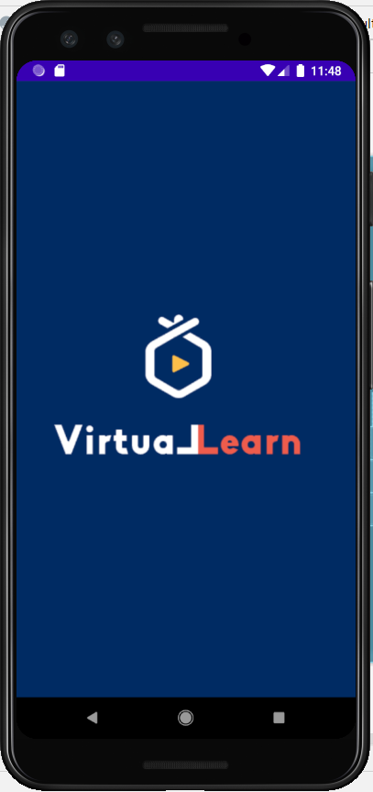 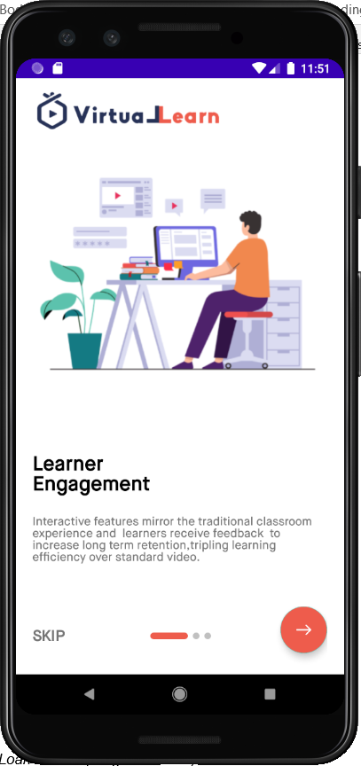

*8.1.1: Splash Screen. 8.1.2: App Tour Screen 1*

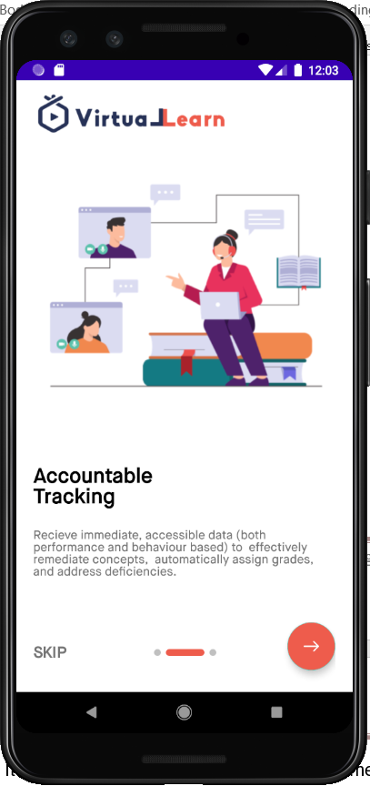 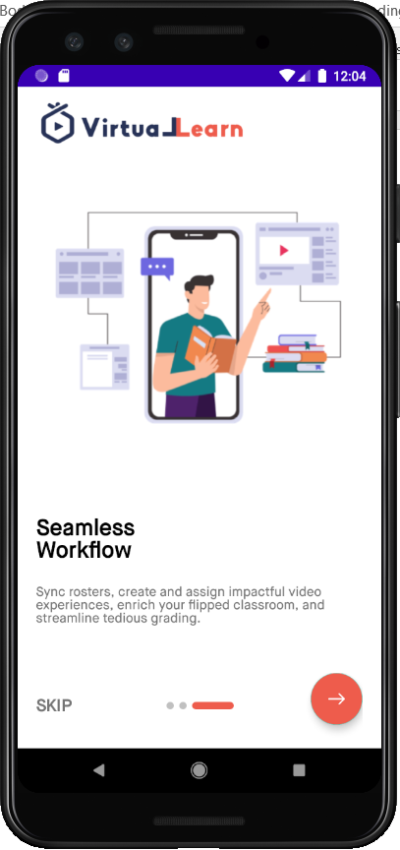

*Fig 8.1.3: App Tour Screen 3. Fig 8.1.4: App Tour Screen 4.*

**8.2 Login and Registration:**

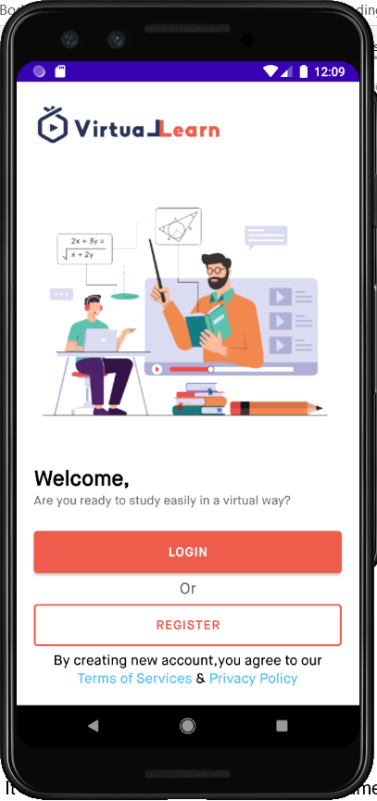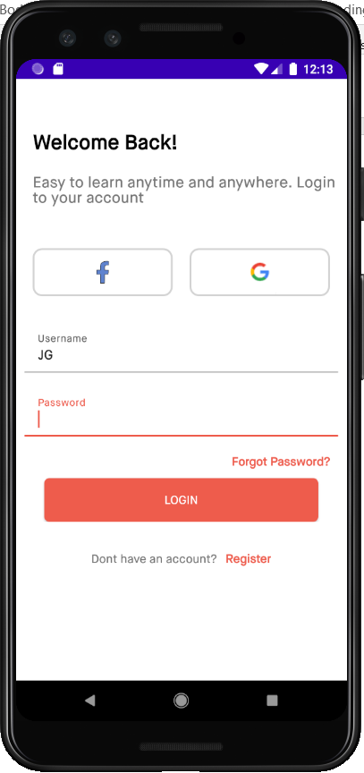

*Fig 8.2.1: Welcome Screen Fig 8.2.2: User Login.*

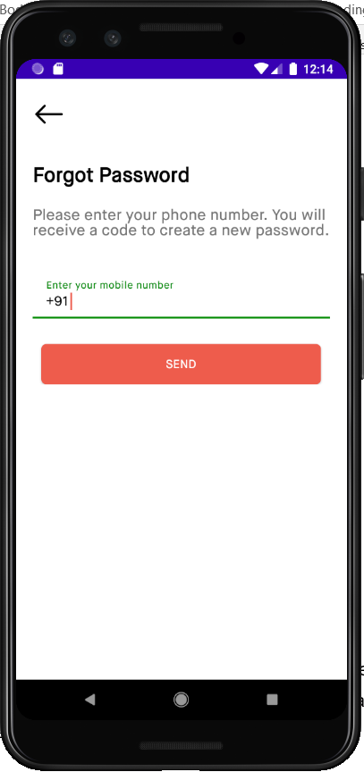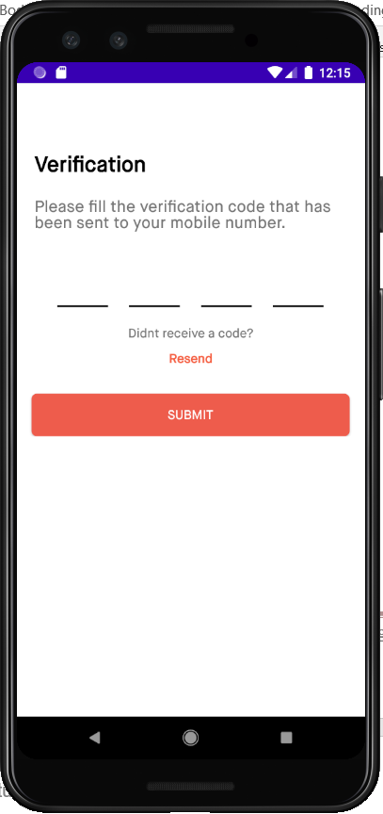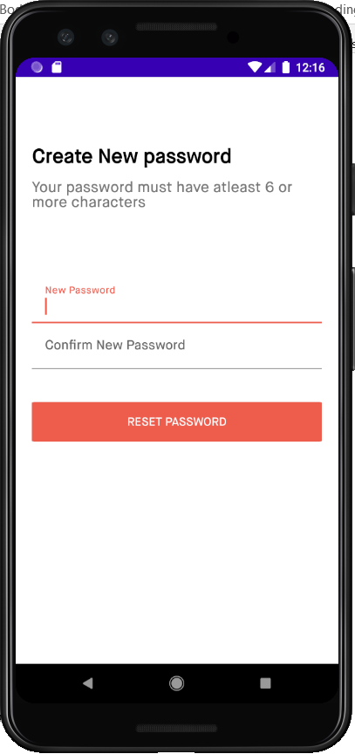

*Fig 8.2.3: Forgot Password. Fig 8.2.4: OTP Verification. Fig 8.2.5: Reset Password.*

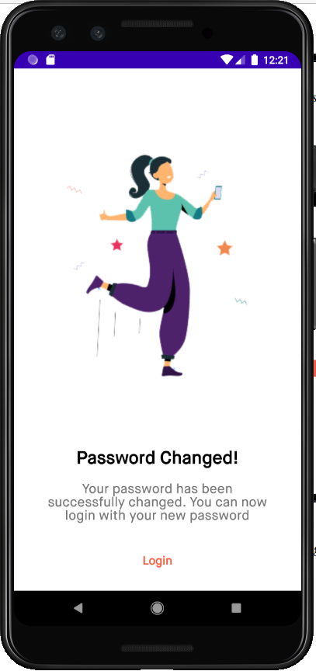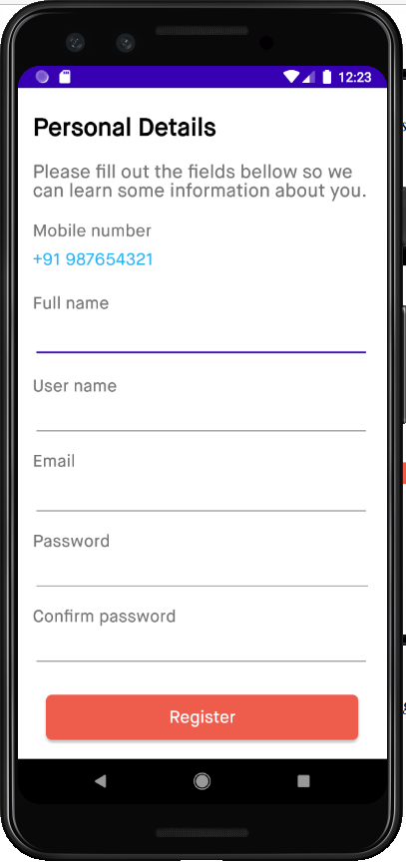

*Fig 8.2.6 Reset Password Successful. Fig 8.2.7: User Registration.*

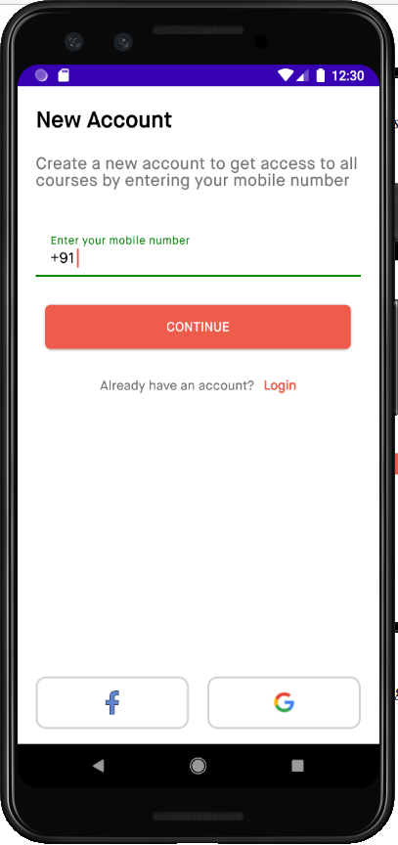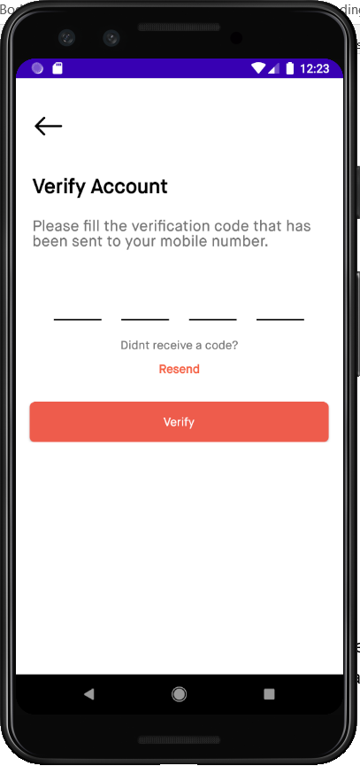 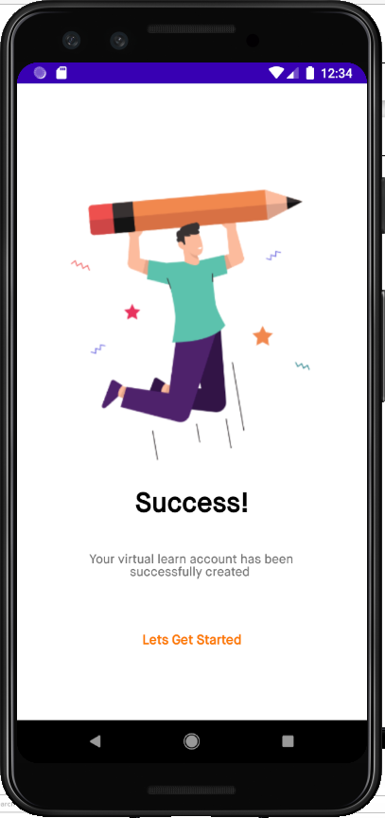

*Fig 8.2.8:Mobile Number Register Fig 8.2.9: OTP register. Fig 8.2.10 Register Successful.*

**8.3 Menu:**

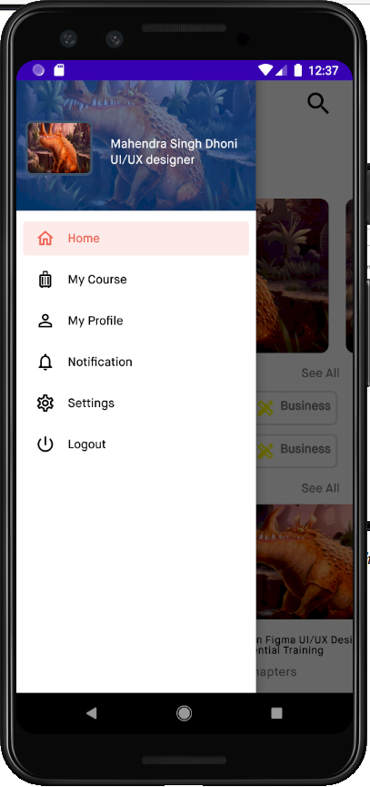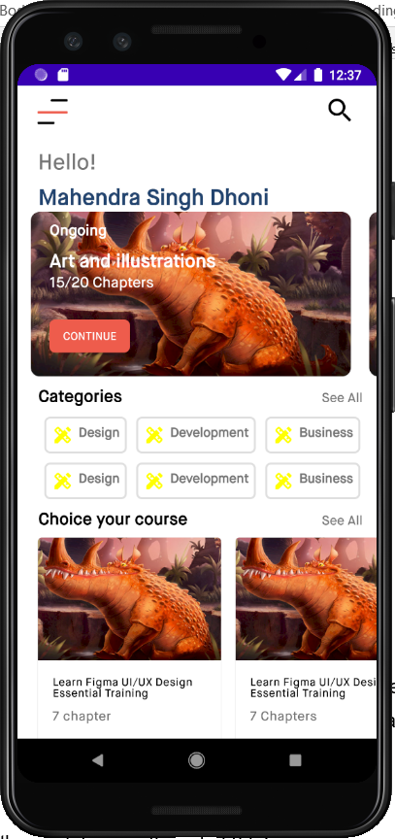 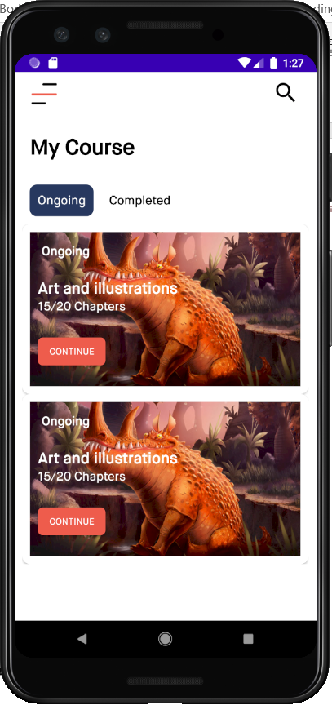

*Fig 8.3.1: Drawer. Fig 8.3.2: Home. Fig 8.3.3: My Course.*

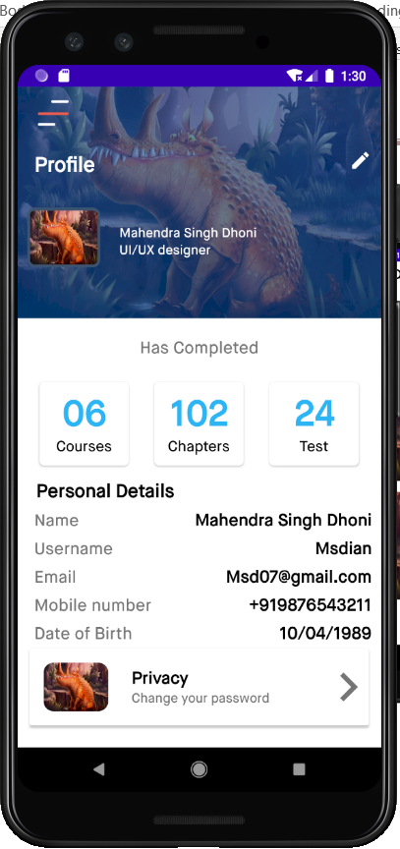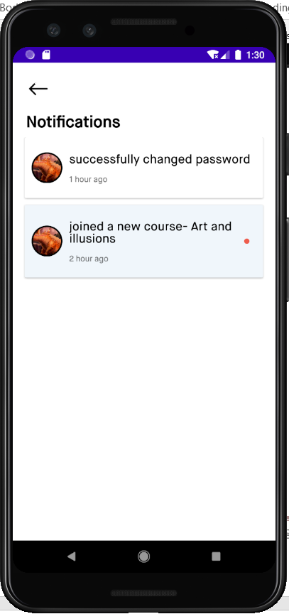 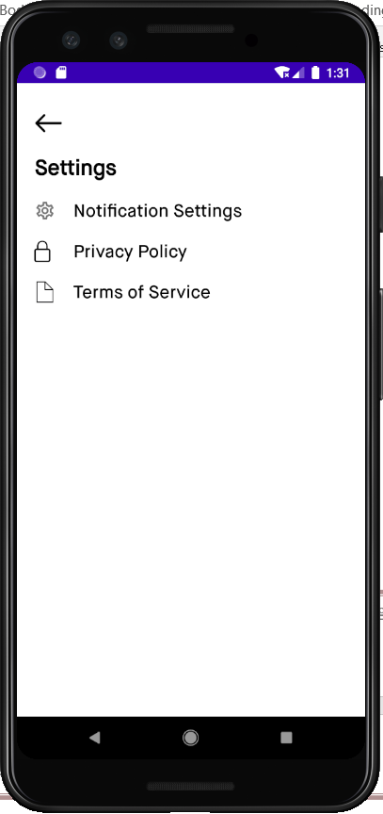

*Fig 8.3.4:My Profile Fig 8.3.5: Notification. Fig 8.3.6: Settings.*

**8.4 My Course:**

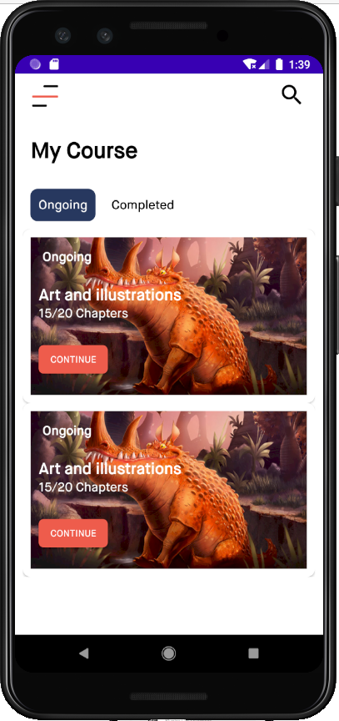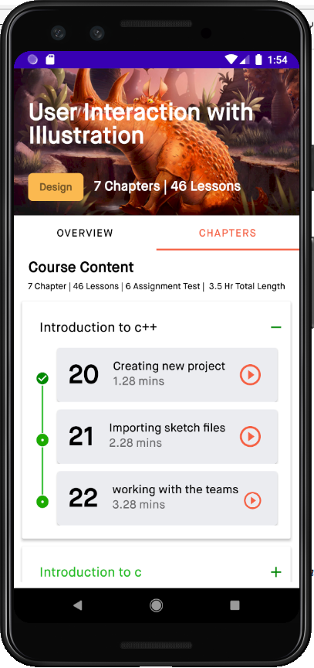

*Fig 8.4.1: Ongoing courses. Fig 8.4.2: Ongoing Course detail screen.*

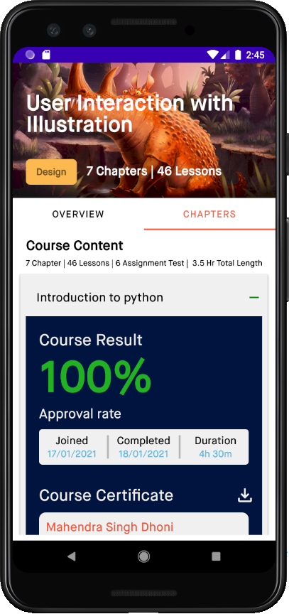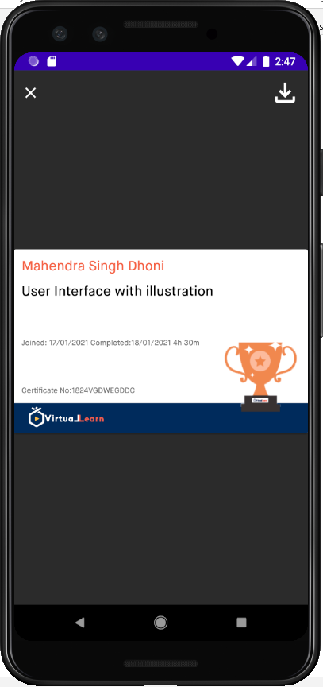

*Fig 8.4.3:Course Completion. Fig 8.4.4: Course Completion Certificate.*

**8.5 My Profile:**

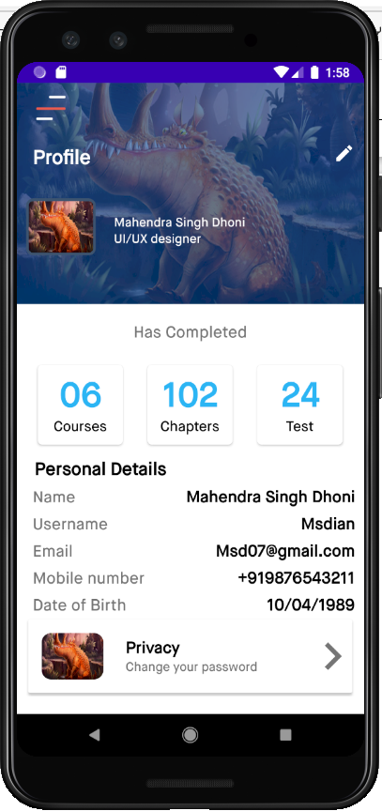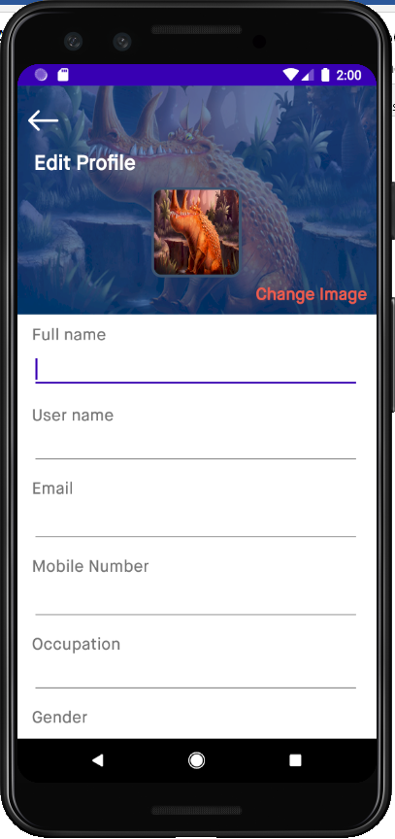 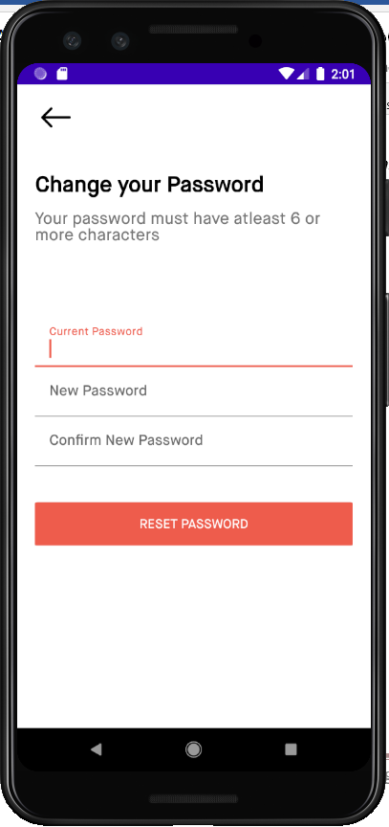

*Fig 8.5.1: View Profile. Fig 8.5.2: Edit Profile. Fig 8.5.3: Change Password.*

**8.6 Notification and Settings:**

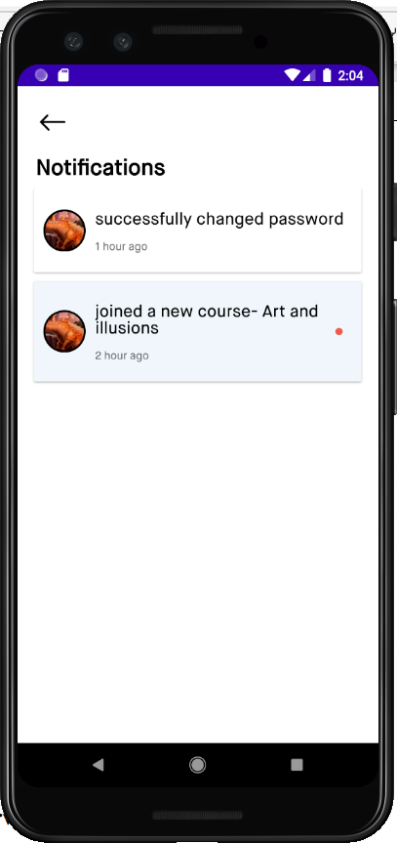

*Fig 8.6.1 : Notification.*

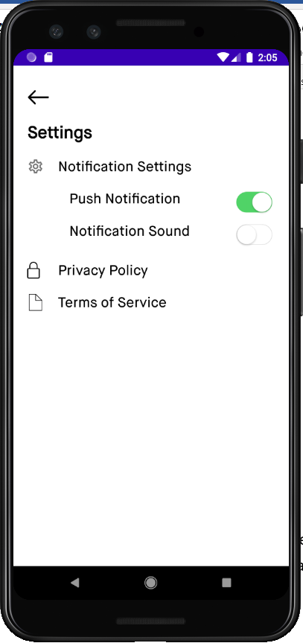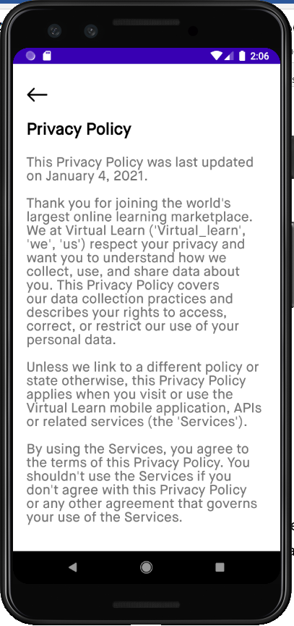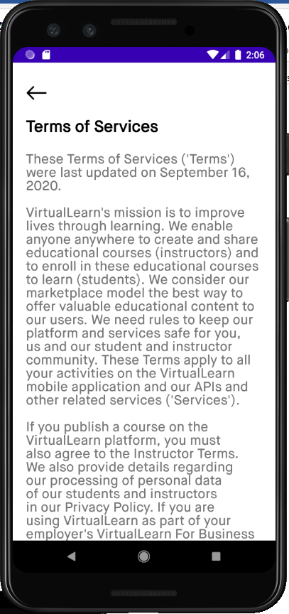

*Fig 8.6.2:Notification settings. Fig 8.6.3:Privacy Policy. Fig 8.6.4:Terms of Service.*

**8.7 Test:**

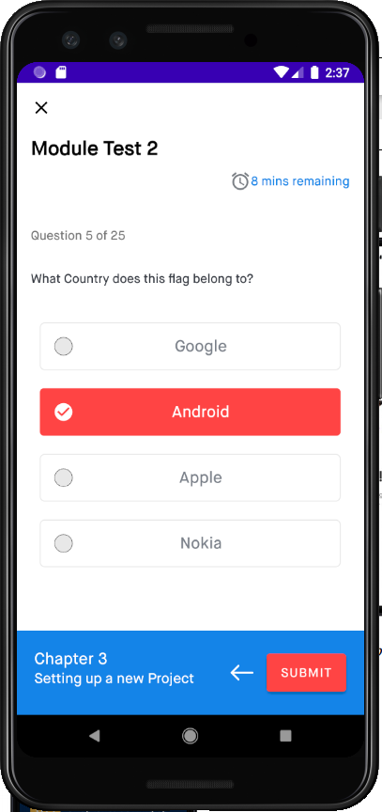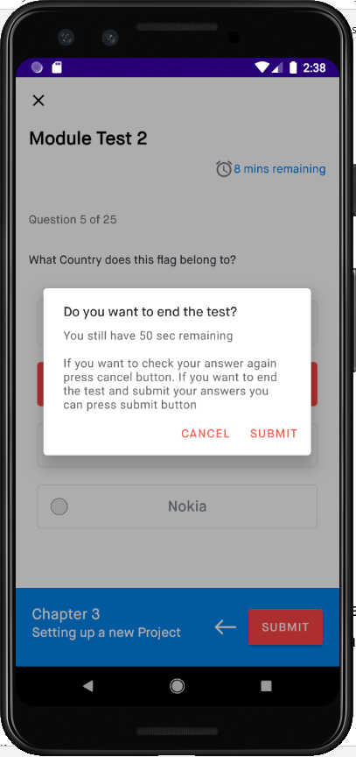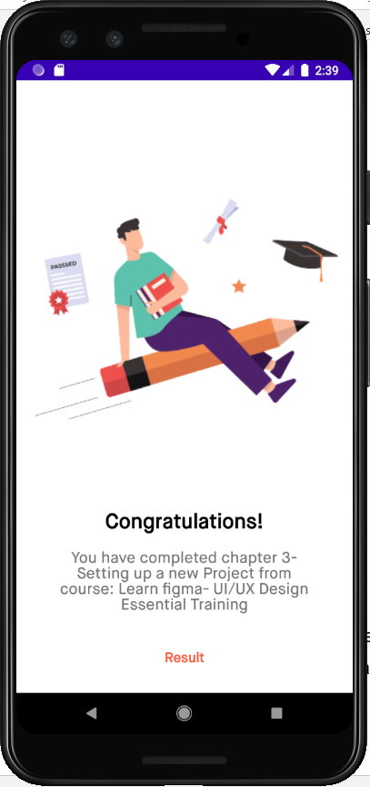

*Fig 8.7.1: Test. Fig 8.7.2: Submit Test. Fig 8.7.3: Test Completed.*

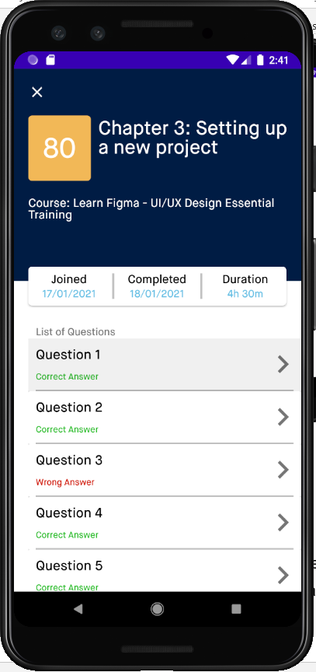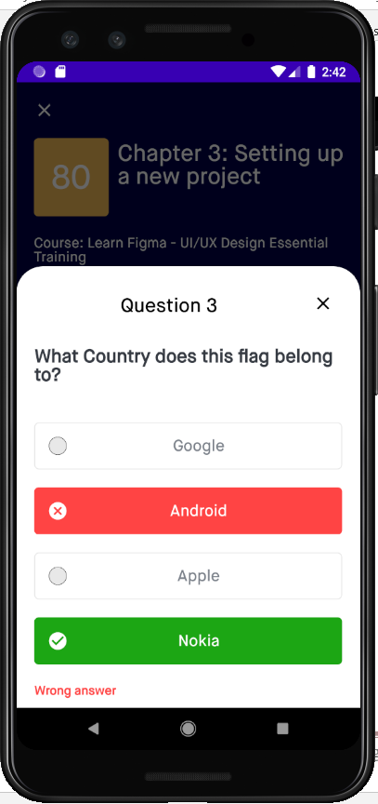

*Fig 8.7.4: Course Result. Fig 8.7.5: Review Result.*

### 8.8 DISCUSSIONS

The main purpose of our project is to make the proper of learning easy for learners and more comfortable as they can use our app to learn their subjects at home. Our project mainly aims at making the process time saving and more understanding. For this purpose we have developed a virtual learning app wherein we have added features like search enable the user to browse and watch the courses which they require. This feature will help the learners in saving their time to look for videos from the entire lot of videos. The quiz feature also enables the users to test their skills through variety of tests. It benefits Students, Research Scholars, IT enthusiasts.

**CHAPTER 9**

**CONCLUSION AND FUTURE WORK**

### CONCLUSION

E-Learning is a part of redefinition of how we transmit knowledge and skills to generations of learners, and is not just a change of technology. The projects helps in improving the skills of the learner, making the process of learning interesting. Multiple features provided to the users on our software benefits in understanding the learners’ necessities. Quizes is conducted in between the courses which helps to understand the amount of knowledge they have gained help learners to boost their confidence level. The personalization in e-learning is described as a composition of procedures and techniques for giving the students the tools for self-learning, which will give them the opportunity to study according to their own interests, needs and learning style.

### FUTURE WORK

The system that we have currently developed has multiple features that benefits the learners while interacting on the app. Further we want to focus more on making the app more user-friendly and appealing to the learners of smaller ages to find the process more fun and engaging. We plan to focus on improving the overall performance of the system. Creation of a discussion forum that would be the base for the interaction between the learners and the lecturers on the app that would allow the learners to clarify any kind of doubts they would have regarding the subjects they would be dealing with. Updating the app with admin and videos of different criteria, higher quality videos, etc., would be a part of our future development. We are also focusing on developing an web application for our model which is a better platform for interaction and each user can browse in their phones for flexible use.

**REFERENCES**

1. Dionisia Laranjeiro, “Development of Game-Based M-Learning Apps for Preschoolers”
2. N A Handoyono and Rabiman,“ Development of android-based learning application in EFI materials for vocational schools”
3. A D Achmad, A Achmad, and Z M Putra, “Interactive Learning Media Based on Android for Computer Programming Course”
4. Nia Gracelita, “Development of e-learning and statistical simulation for explorative data analysis based on android”
5. Surya Pratama and Adi Jaya Putra,”Developing Android Based English Vocabulary Learning Materials for Primary School Students”
6. L. Rivas, “Development and Application of an App for Virtualized Learning of Scientific and Medical Terminology”
7. Y Roza, S N Siregar, S Salam and A Adnan, “Android based e-learning tutorial for mathematics teachers”
8. Muzayyanna, Riswandi, Helmi, Akla, “Application Based Android As A Development Of English Learning Media”